IFN006 Research Information Strategy Report
Student name: Oriolson Rodriguez Ramirez
N 12608521
Faculty of Science
School of Mathematical Science

Research question: How to build a MARL simulation, parametrized by preference vectors, to predict consensus output?

Contents
1. Introduction 2
2. Research question 3
2.1. Research Question 3
2.2. Research Concepts 3
2.3. Keywords, synonyms and related terms 3
3. Database 3
4. Search strategy 3
4.1. Formulate search statement 3
4.2. Search strategy development 3
4.3. Search results analysis 3
5. Information management strategy 3
5.1. Reading and taking notes 3
5.2. Storing and organising literature 3
5.3. Managing references 3
5.4. Documenting your searching 3
6. Current awareness strategy 3
6.1. Strategy 1: 3
6.2. Strategy 2: 3
6.3. Strategy 3: 3
7. Sample source analysis 3
7.1. Source 1 3
7.2. Source 2 3
7.3. Source 3 3
Reference list (if needed) 3
Appendices (if needed) 4

Introduction
This document shows a detailed Research Information Strategy Report subdivided in sections. It starts with the research question that is part of my research project; this question is decomposed into concepts and keywords that will help construct the string search. Then it shows the database selection followed by the research strategy that contains the search statement add its findings. Afterwards, it will present the Information management strategy followed by the current awareness strategy where the document will show how to keep the researcher updated with the latest development in its field. Finally, he will move to the analysis of some sources, in this section three provided sources will be analysed for authenticity and other important aspects that are part of any academic researcher's life when handling sources and references.

Research question

Research question
The following Research equations is the third question of a set of three that is part of my research project, for the purpose of this document only the third one will be analysed
Research question: How to build a MARL simulation, parametrized by preference vectors, to predict consensus output?
These projects use natural language processing to analyse diplomatic text that has been submitted to The Antarctic treaty consultative meetings (ATCM) that take place every year. The first and second part of this project contain two questions that are focused on extracting, out of the diplomatic text, the positions or vectors of different countries throughout the history of the ATCNs. Then these vectors are the parametric vectors, in the question above, are used to build a multi-agent reinforcement learning (MARL) simulation, to match the historic outputs of the ATCM, and then predict the outputs of future ATCMs, which happens to decide everything through consensus.

Research concepts
To build a structured search string, the research question is deconstructed into research concepts. These concepts are deconstructed further into keywords.
The research concepts that were found in this question are the following:
- MARL simulation.
- Parametric preference vectors.
- Consensus output prediction.
Three research concepts spanned three different fields that define the scope of the literature search. The first one is computer science, i.e., deep learning. The second one is game theory and negotiation theory. And the third one is consensus dynamics and prediction, which belong to a bigger area, which is international relations.
Following section, the document shows a set of synonyms, related terms, and keywords that will be used for the search string in the database.

Keywords, synonyms and related terms
In order to find synonyms and related terms that may be used by researchers when publishing studies that are relevant to our literature review, the research concept is decomposed into keywords. These keywords are the second column in table 1. The first column shows the concept that these keywords were derived from, and the third column shows the related terms or synonyms that will be used for our literature search.
Research concept | Keyword | Synonyms | Related terms
MARL simulation | Multi-agent reinforcement learning (MARL) | multi-agent RL; decentralised reinforcement learning | agent-based simulation; Markov/stochastic games; multi-agent systems
Parametric preference vectors | Preference vector | preference weights; preference-conditioned policy | multi-objective reinforcement learning (MORL); scalarisation; reward weighting
Consensus output prediction | Consensus | Absolute agreement;  aggregated output | consensus algorithms; ensemble prediction; voting/aggregation; Unanimity

Database
Considering that the research concepts span four different fields: computer science for agent simulations, applied mathematics and linear algebra for parametrized vectors, game theory and international relations literature for consensus dynamics. The selected database needs to have access to all these field to avoid missing relevant information.
It is also important that this database captures most of the papers that are presented in different conferences, since a big part of computer science papers are presented in this type of events.
Considering the above criteria, the selected database is Scopus. This database was selected using five different criteria:
- The first one was comprehensiveness. It contains more than one hundred million records across three hundred and thirty subject areas. It also contains all the needed literature from different areas: RL simulation, algebra, game theory, and international relations.
- The second criteria are scope and coverage. It is multidisciplinary and cross-publisher. That means that it checks also in IEEE database, ACM, Springer, Elsevier, and other social sciences journals.
- The third criterion is quality. All the papers that are there are peer-reviewed and curated. There is an independent content selection in Scopus. It also does not contain grey literature or preprints.
- The fourth criterion is the search interface, syntax, and the algorithm. It facilitates all the Boolean and field-targeted searching that are needed for our search. For example, proximity operators, wildcards, etcetera.
- The fifth criterion is usability. It is easy to access since it is web-based.

Search strategy

Formulate search statement
The initial goal is to build the research statement using table 1, going row-wise (i.e. per research concept). Per row, the keywords, synonyms and related concepts of the first research concepts are joined using OR Boolean operators, except when the terms are necessarily mutually exclusive. Likewise, the other table rows. The resulting strings from each table row are joined together using AND Boolean operator to restrict the results to very interdisciplinary studies and they are applied are fields search on title, abstract and keywords.
Since there are several multi-word terms, phrase searching was applied in several places of the search statement, for example, “MARL simulation” and “multi-object reinforcement”. Furthermore, nesting terms were used to group synonyms and truncations for the words that are common with variation, for example, “reinforc*” which can take the form of “reinforcement” or “reinforced”.
The resulting search statement is:
TITLE-ABS-KEY ( "multi agent reinforcement learning" OR "multiagent reinforcement learning" OR marl OR "decentrali?ed reinforcement learning" OR "stochastic game*" OR "markov game*" OR "agent based simulat*" ) AND ALL ( "preference vector*" OR "preference weight*" OR "weight vector*" OR "preference condition*" OR "multi objective reinforcement learning" OR morl OR scalari?ation OR "reward weight*" ) AND ALL ( consensus OR "collective decision*" OR "group decision*" OR "emergent agreement" OR "joint policy" OR "joint policies" OR "policy aggregation" OR coordinat* OR "social welfare" ) AND ( LIMIT-TO ( SRCTYPE , "j" ) ) AND ( LIMIT-TO ( DOCTYPE , "ar" ) OR LIMIT-TO ( DOCTYPE , "re" ) )
The results of the application of the above statement in Scopus filtered by only include Journals as Source type, and Article and Review as Document Type are presented in figure 1.
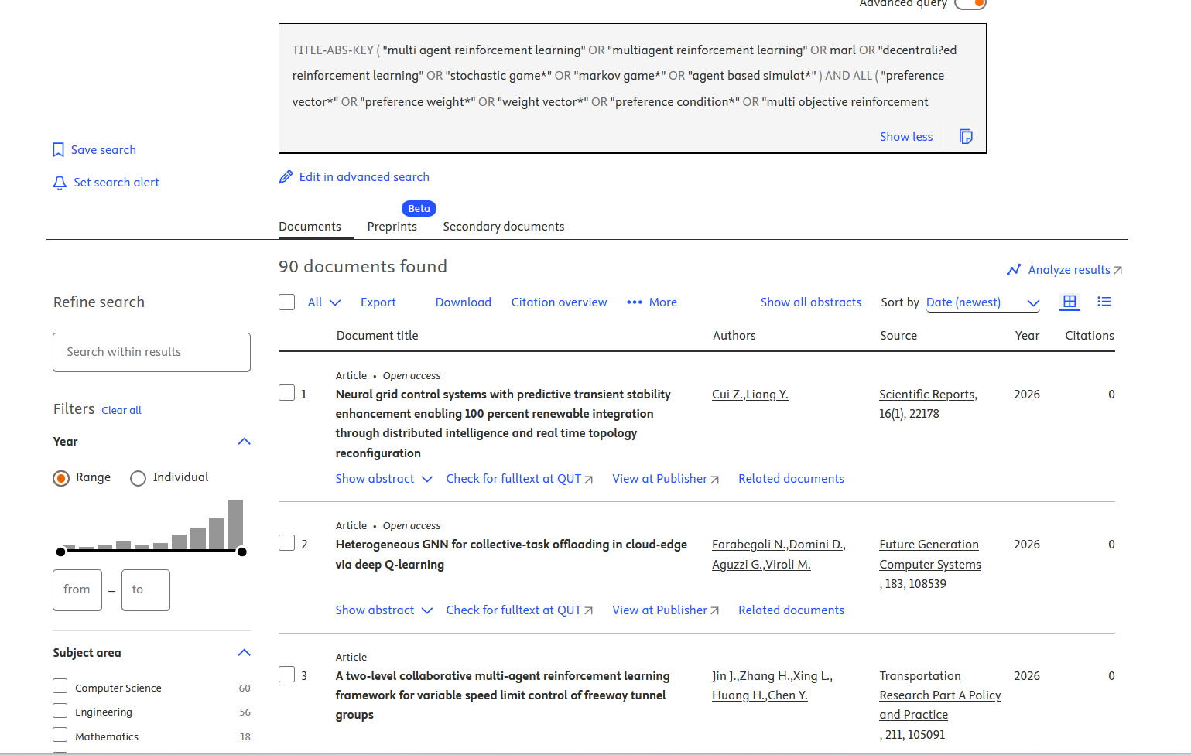

Search strategy development
The final research statement is build iteratively, starting from the most restrictive search and the expanding it to a reasonable number of results. The first research statement outputs only three articles (see figure 2). Even though they are from the right disciplines, there are still too few to be considered a good search. Therefore, some of the restrictions of the statement (i.e. AND Boolean operators and restricted field search) need to change.
From the three research concepts, the most restricted one is consensus. That is because, usually, computer science and mathematics are interrelated, and they show up in several resources together. That is because computer science uses mathematical innovations to work, and, sometimes mathematicians use computers to compute numbers. Therefore, the most restrictive term is consensus, or the research concept where consensus or unanimity is mentioned. That is because being a decision-making system makes it the less likely to show up together with computer science and mathematics. There is where all the work needs to focus to improve our search, at least in the first iterations.

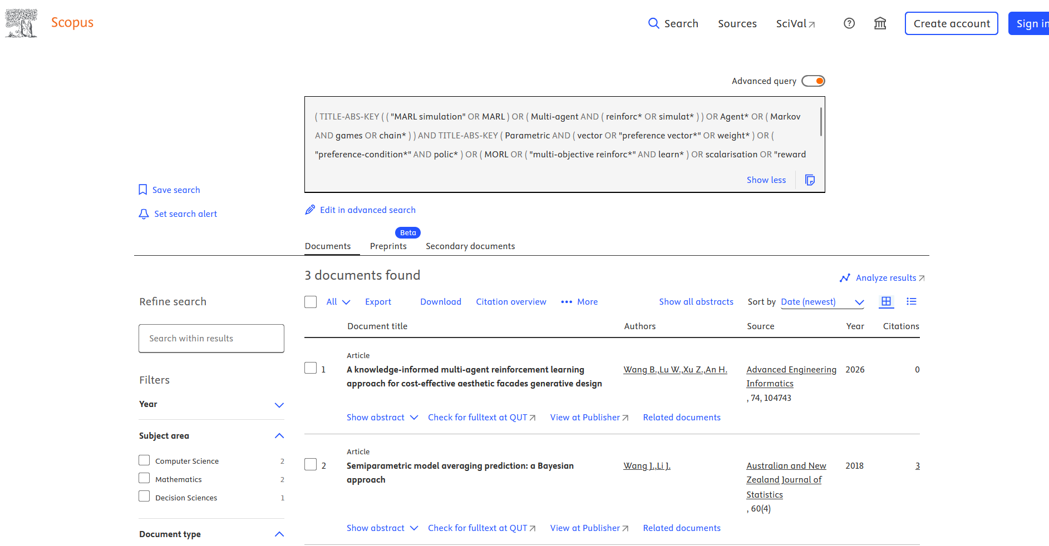

Changing the last part to ALL fields instead of just TITLE-ABS-KEY, produces 2 results (see figure 3).
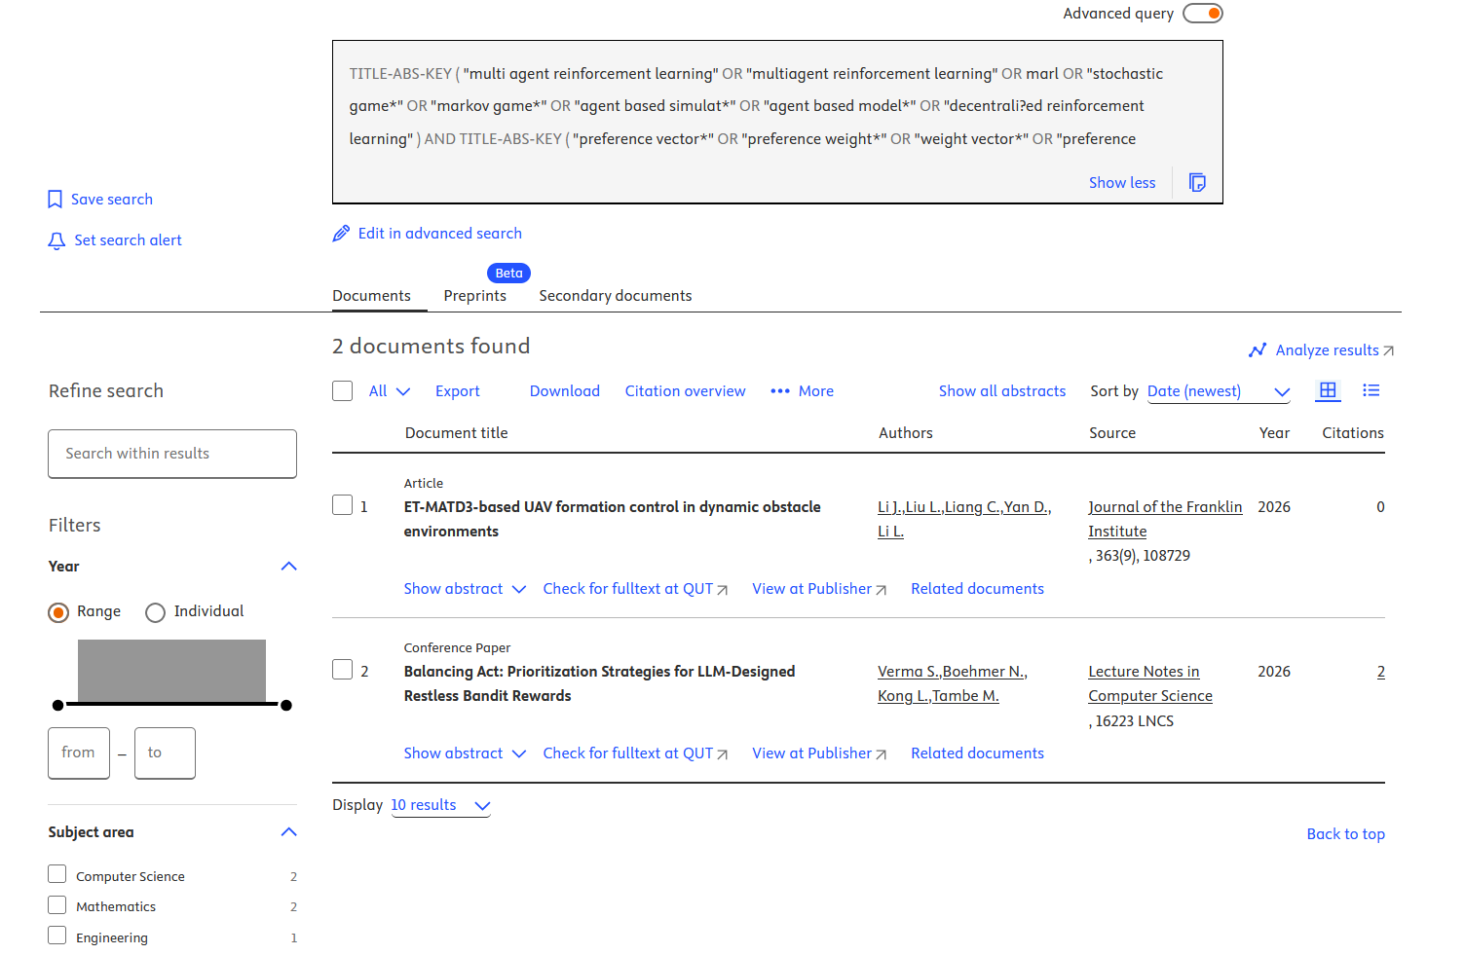

When changing the format and the way of writing the third sub-research statement that handles the consensus and unanimity terms, it always gives us very, very few results. Therefore, a further test is needed to try to test our hypothesis about the restriction that this third concept represents. If it happens to be true, it means that we need to revisit the research concept to try to find better terms in the consensus part. The hypothesis is that maybe the third concept, with its keywords, related terms, and synonyms, are not fraimed well. When removing the third concept from the research statement, the search results Figure 4 shows the expansion of the results to 77. This confirms the hypothesis about Consencus term being the restrictive factor.
‘
Therefore, for this third research concept — synonyms: absolute agreements, and aggregated outputs are changed for collective decision, group decision, and emergent agreement. Related terms: consensus algorithms, ensemble prediction, both-in aggregation, and unanimity are changed to joint policy, policy aggregation, coordination, and social welfare. The refined table is the following
Research concept | Keyword | Synonyms | Related terms
MARL simulation | Multi-agent reinforcement learning (MARL) | multi-agent RL; decentralised reinforcement learning | agent-based simulation; Markov/stochastic games; multi-agent systems
Parametric preference vectors | Preference vector | preference weights; preference-conditioned policy | multi-objective reinforcement learning (MORL); scalarisation; reward weighting
Consensus output prediction | Consensus | collective decision; group decision | emergent agreement joint policy; policy aggregation; coordination; social welfare

Using the same strategy as described in the previous section, provides the research statement that is used to output ninety results that seem to have good quality. All those results belong to the disciplines that this report considers important. Therefore, this is considered the final research statement.

Search results analysis
The criteria that is used to evaluate the results is the following: First, it will start with the quality of the results. Second, it will evaluate the scope of the results. And third, it will evaluate if the results belong to the disciplines that are relevant to the research question and the project itself.
The ninety results obtained from the search statement are already filtered out to only show journals that are peer-reviewed, and it only shows articles and reviews. Therefore, the quality of the results is ensured by showing only articles from peer-reviewed journals.
The scope of the results is evaluated based on the years of publication and the range of the whole set of articles that search outputs. The years of publication range from 2017 to 2026, it reflects the fact that this multi-disciplinary field is very recent. Only when the graphic processing units, GPUs, were developed and made public, they made artificial intelligence, and more specifically, multi-agent reinforcement learning, possible. That's the starting point of this specific field, and that occurred between 2015 and 2020, in the research labs. And this matches the dates of publication of the resulting articles.
Finally, the results' relevance is evaluated based on the number of disciplines that the research articles belong to. In this case, most of the articles belong to computer science, engineering, mathematics, social science and decision science, which are actually the core of the research. Even though most of the results belong to the field this research question is focused on, there are around seven results that are from other disciplines that are unrelated. For example, medicine, earth and planetary sciences, biochemistry, genetics and molecular biology, and chemistry. These fields are filtered out.

Information management strategy
Due to the high number of research articles that the strategies output (i.e. 90 in this case). The existence of an information management strategy is fundamental to the success of a research project during the whole research degree.
For that reason, in the following sections, there will be a description of all the different steps that are taken to read, organize, store, classify, annotate, and retrieve the information in an efficient and organized way.

Reading and taking notes
All articles are filtered by reading the title, abstract and keywords first, this discard some of the irrelevant ones. Subsiquently, the selected list of articles are input into Zotero, including the actual pdf. During this step all type of syncing is disable do avoid the pdf being uploaded to external servers.
The Zotero pdf reader in used locally, this reader allows writing and annotating over the pdf and storing those comments and pdf text systematically for later referencing. Exporting references can be done in Zotero or in any other software tool.

Storing and organising literature
For storing and organizing literature Zotero software is being used to Store medata (title, abstract, authord, DOI etc) and the pdf itself. The syncing Zotero feature is disable in order to prevent the pdf being uploaded to unwanted server.
Using Zotero and using its collections capabilities the articles are classified according to its purpose: methodology, framework, application or review.

Managing references
Zotero is used as the primary reference manager using it pluging to Word text editor. This allows the direct referencing of in-text citations directly from Zotero. Since, all articles are imported directly from Scopus, the whole process does not require manual data entry.

Documenting your searching
The search is documented using Scopus build-in feature to save search string and results (See picture below). This will allow the tracking every search with its results and date. Furthermore, in case of extra comments need to added a md file will be kept in one drive that links the search with the log entry comments.
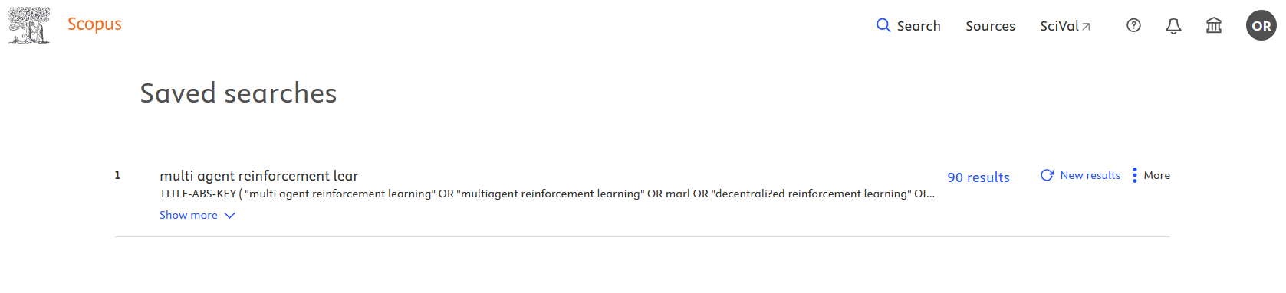

Current awareness strategy
In Artificial Intelligence related field the advace and of scientific knowledge is staggering in the las decade. This makes a awareness strategy necessary to keep the pace of the of cutting edge .

Strategy 1:

Strategy 2:

Strategy 3:

Sample source analysis

Source 1

Source 2

Source 3

Reference list (if needed)

Appendices (if needed)
Everything in your appendices should have a purpose. They should be labelled clearly and referred to in the body of the report.
This may include
- Complex search strings
- Images, including screenshots
More details can be found here: https://apastyle.apa.org/style-grammar-guidelines/paper-format/appendices

